Predictive Analytics Report

1. Problem framing

This project predicts the next-day volatility regime of the Cboe Volatility Index (VIX). VIX summarises the market’s expectation of S&P 500 volatility over the next 30 days, inferred from SPX option prices. Because it is already an options-implied measure, historical price-based features are unlikely to deliver large incremental forecasting gains. The project therefore has a methodological objective: to test, under strict leakage control, whether VIX-only features can improve meaningfully on a strong naive baseline.

The task is formulated as a one-step-ahead three-class classification problem. The unit of analysis is a trading day. For each day t, the model uses information available at the close of day t to predict the volatility regime at the close of day t+1. Let C_t denote the VIX close on day t. Regimes are defined as:
- Low: C_t \le 15
- Medium: 15 < C_t \le 25
- High: C_t > 25

The supervised target is:

y_t = R(C_{t+1})

where R(\cdot) maps the next-day VIX close into one of the three regimes. The final row is dropped because no t+1 close exists.

The dataset contains daily VIX OHLC observations from January 1990 to February 2026. All predictors are derived from the VIX series itself. This narrow information set is intentional: it simplifies leakage auditing and lets the analysis isolate how much predictive value is available from the series alone.

Performance is evaluated primarily with macro-averaged F1, rather than accuracy, because the regime classes are imbalanced. Two baselines anchor the analysis. The first is a majority-class dummy classifier. The second, and much more important, is persistence: predicting that tomorrow’s regime will equal today’s regime. This baseline is the key comparator because volatility regimes are known to cluster. The central empirical question is therefore not whether a model can beat the dummy classifier, but whether any model can beat persistence in a statistically meaningful way.

2. Exploratory data analysis
The full-sample VIX distribution is strongly right-skewed, with most observations concentrated in calmer conditions and occasional extreme spikes during crisis periods. Regime frequencies are approximately 32% Low, 50% Medium, and 17% High.

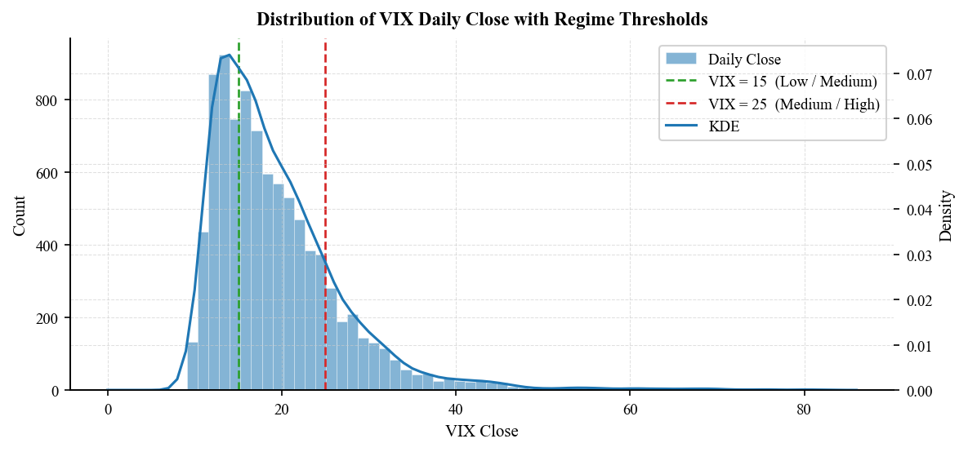
This class imbalance justifies the use of macro F1 as the primary evaluation metric.

The time-series plot shows pronounced volatility clustering, with sustained elevated-volatility episodes during the Global Financial Crisis, the 2011 European debt episode, and the COVID-19 shock.

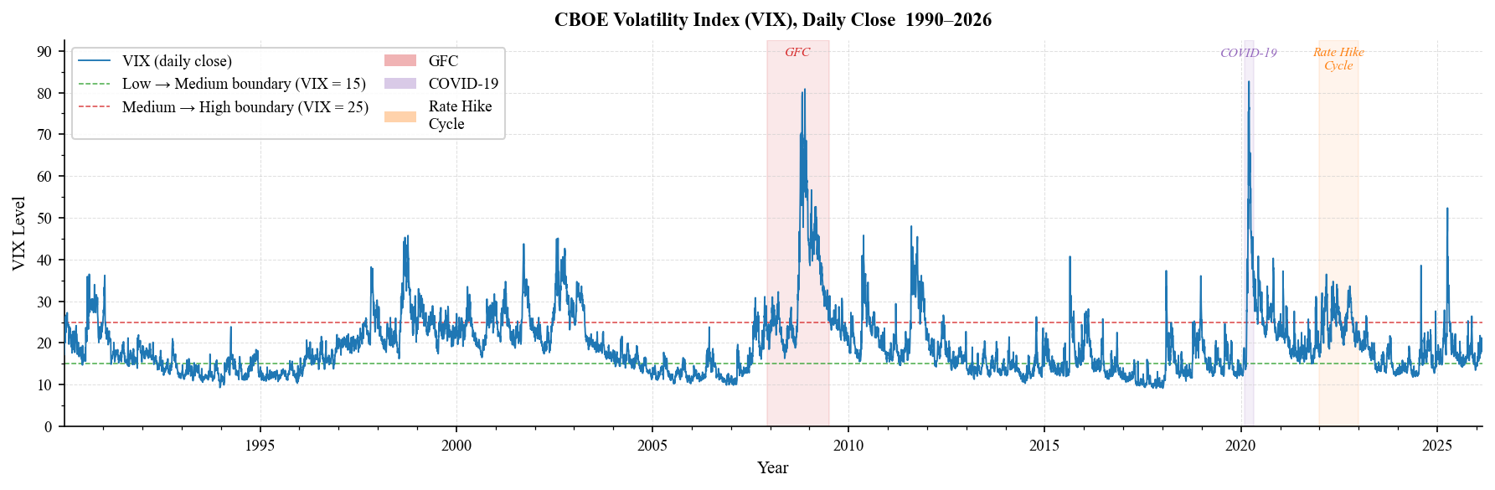
VIX time series Lag-1 autocorrelation of the VIX close exceeds 0.98, confirming strong day-to-day persistence in volatility levels.

Conditional on today’s regime, the probability of remaining in the same regime tomorrow is 92.7% for Low, 91.7% for Medium, and 89.7% for High. These persistence rates explain why the naive carry-forward rule is a strong benchmark.

Given the observed class frequencies (Low 32%, Medium 50%, High 17%), the expected macro F1 of a persistence classifier can be approximated directly from the transition probabilities before fitting any machine-learning model. Weighting the diagonal persistence rates by class frequency yields an expected macro F1 of roughly 0.91, which is close to the observed test value of 0.88. The small gap is explained by asymmetric errors on the minority High regime.

The key challenge is therefore not classifying persistent same-regime days but anticipating the relatively rare transition days, meaning improvements over the persistence benchmark are likely to be modest.
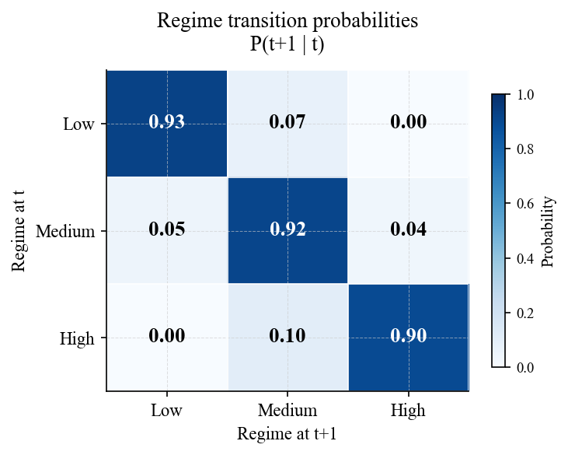

A feature correlation heatmap further shows strong collinearity among lagged levels and rolling summaries, especially between lagged closes and the 21-day mean. This does not by itself imply that the decision boundary is linear, but it does suggest that the effective dimensionality of the feature space is lower than the raw feature count implies. In combination with the strong persistence captured by current_regime, this makes a regularised linear classifier a plausible candidate. By contrast, highly flexible tree ensembles may be more vulnerable to learning regime-specific patterns that do not generalise well across decades.

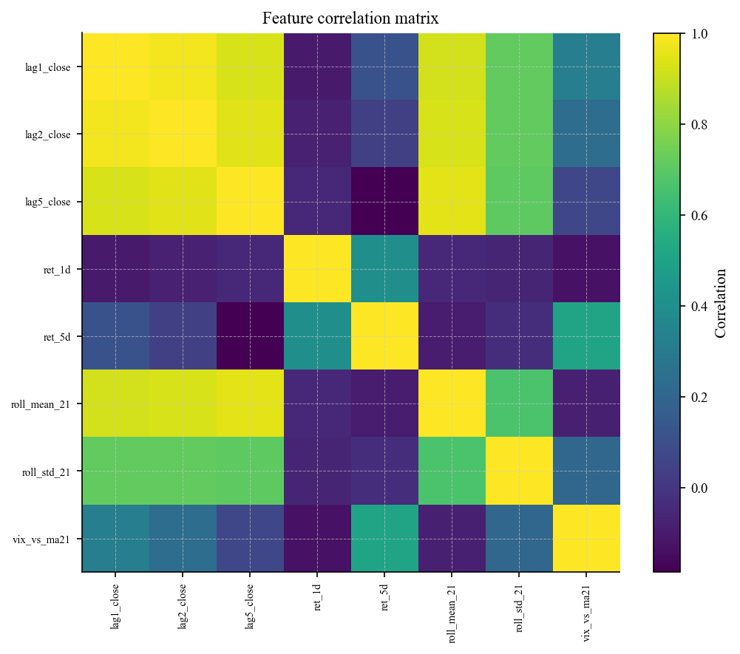

3. Data preparation and feature set

The target variable is created by shifting the VIX close forward by one day and applying the regime mapping to C_{t+1}. This preserves a genuine forecasting setup: predictors at time t are used to predict a regime realised at t+1.

The final modelling feature set contains nine predictors, all derived from information available by the close of day t:
- lag_1, lag_2, lag_5: lagged VIX closes, capturing short-horizon persistence over daily and weekly horizons
- ret_1d, ret_5d: one-day and five-day log returns, capturing recent directional movement
- ma21, vol21: 21-day rolling mean and rolling standard deviation of the lagged close, summarising recent level and dispersion
- vix_vs_ma21: deviation of the lagged VIX close from its 21-day moving average
- current_regime: the regime observed at time t, ordinal-encoded for modelling and used to capture the strong state persistence documented in the transition matrix

This feature set is important to state precisely because it determines the interpretation of the results. In particular, vix\_vs\_ma21 gives the model a direct measure of whether volatility is currently elevated relative to recent history, while current_regime lets the model exploit the strong state persistence documented in the transition matrix.

All rolling statistics are computed on CLOSE.shift(1) rather than the contemporaneous close, so the feature value at time t uses only prior observations. That design is central to the project’s leakage control. Intraday range was examined during EDA but was not included in the final modelling feature set.

The data are split chronologically into train, validation, and test partitions using a 70/15/15 allocation with no shuffling. Features are standardised using a StandardScaler fitted on the training set only and applied unchanged to validation and test sets. A dedicated verification cell in the notebook checks that target construction, rolling windows, split ordering, and scaling all respect the out-of-sample structure.

4. Model exploration
The model comparison includes seven specifications: dummy baseline, persistence baseline, multinomial logistic regression, Random Forest, XGBoost, sklearn MLP, and a PyTorch DeepMLP. The PyTorch network uses three hidden layers (128 → 64 → 32), dropout of 0.20, Adam optimisation with weight decay, and early stopping on validation macro F1. It is included to test whether additional nonlinear flexibility improves classification on the relatively rare transition days.

The transition matrix suggests that the dominant predictive signal is the identity of the current regime, making current_regime an effective proxy for the target at time t+1. Logistic regression is therefore well aligned with the signal structure: it directly models the contribution of each predictor and is well suited to a feature set dominated by categorical regime persistence and strong collinearity among lagged level variables.

Tree ensembles and neural networks can in principle learn the same relationship, but their additional flexibility may be a disadvantage in a dataset spanning structurally different volatility periods. They are more exposed to fitting regime-specific patterns that do not generalise well out of sample.

5. Results and evaluation
Table 1 reports the held-out test results.
Table 1. Test-set model performance
Model | Macro F1 | vs Persistence
Dummy baseline | 0.2654 | −0.6145
Persistence baseline | 0.8799 | —
Logistic Regression | 0.8821 | +0.0022
Random Forest | 0.8677 | −0.0122
XGBoost | 0.8663 | −0.0136
sklearn MLP | 0.8756 | −0.0043
PyTorch MLP | 0.8787 | −0.0012

The main result is that persistence is already extremely strong, with a macro F1 of 0.8799, closely matching what the transition matrix would imply. Logistic regression records the highest point estimate, but the improvement is very small at +0.0022 over persistence. The PyTorch DeepMLP almost matches the baseline but does not exceed it, while the sklearn MLP, Random Forest, and XGBoost all underperform.

This ranking is informative. Logistic regression performs best because the predictive structure is dominated by regime persistence and is therefore close to linear. The PyTorch model’s near-match to persistence suggests that additional depth can fit the data without uncovering materially new signal. Tree ensembles perform worst, consistent with the idea that non-stationary volatility structure across 1990–2026 penalises models that rely on flexible splits learned from earlier regimes. The gap between the two neural models also appears architectural rather than framework-related: the PyTorch implementation uses dropout regularisation and early stopping on validation macro F1, both of which likely improve generalisation relative to the sklearn MLP.

Across 1,367 test observations, only 28 prediction outcomes differ between logistic regression and the persistence baseline, yielding a McNemar exact-test p-value of 0.85. The observed difference is therefore consistent with chance.

More importantly, the small number of discordant pairs implies that the test has very limited statistical power. To reject the null hypothesis at p < 0.05, a materially larger number of prediction differences would be required, which in practice would mean extracting genuine additional signal on transition days. Within the current feature set, such gains appear very limited. The null result should therefore be interpreted not as a failed model-selection exercise, but as an empirical bound on how much incremental signal VIX-only features can provide beyond persistence.

Error analysis supports this interpretation. The corresponding failure-mode comparison across the full model panel reinforces the same result: transition days, rather than stable continuation days, are the common source of error for every specification evaluated.

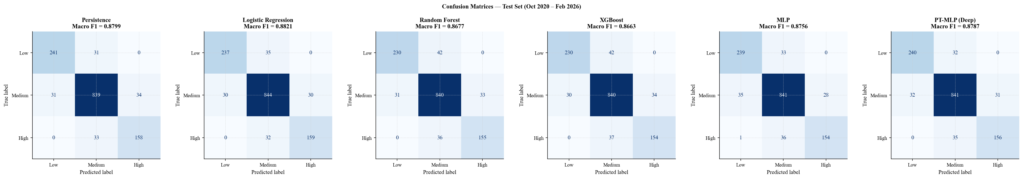
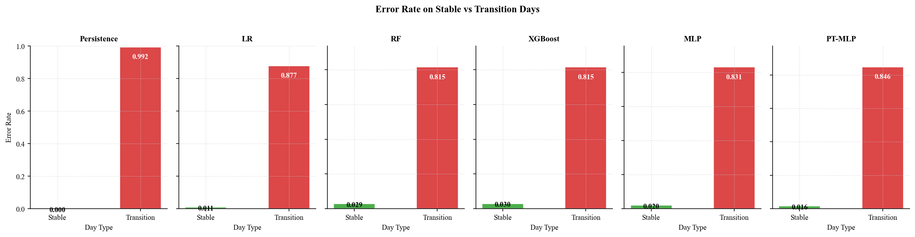
Most errors occur on regime-transition days rather than same-regime continuation days, and this pattern holds across the full model set. Stable periods are classified well by nearly all models because persistence dominates, whereas regime shifts remain the central forecasting difficulty.

Logistic regression does show a small advantage in the High regime, where F1 rises from 0.8251 under persistence to 0.8368. The coefficient plots suggest that the strongest marginal contribution comes from vix_vs_ma21: when lagged VIX is elevated relative to its recent moving average, the model increases the probability of remaining in a stressed state.

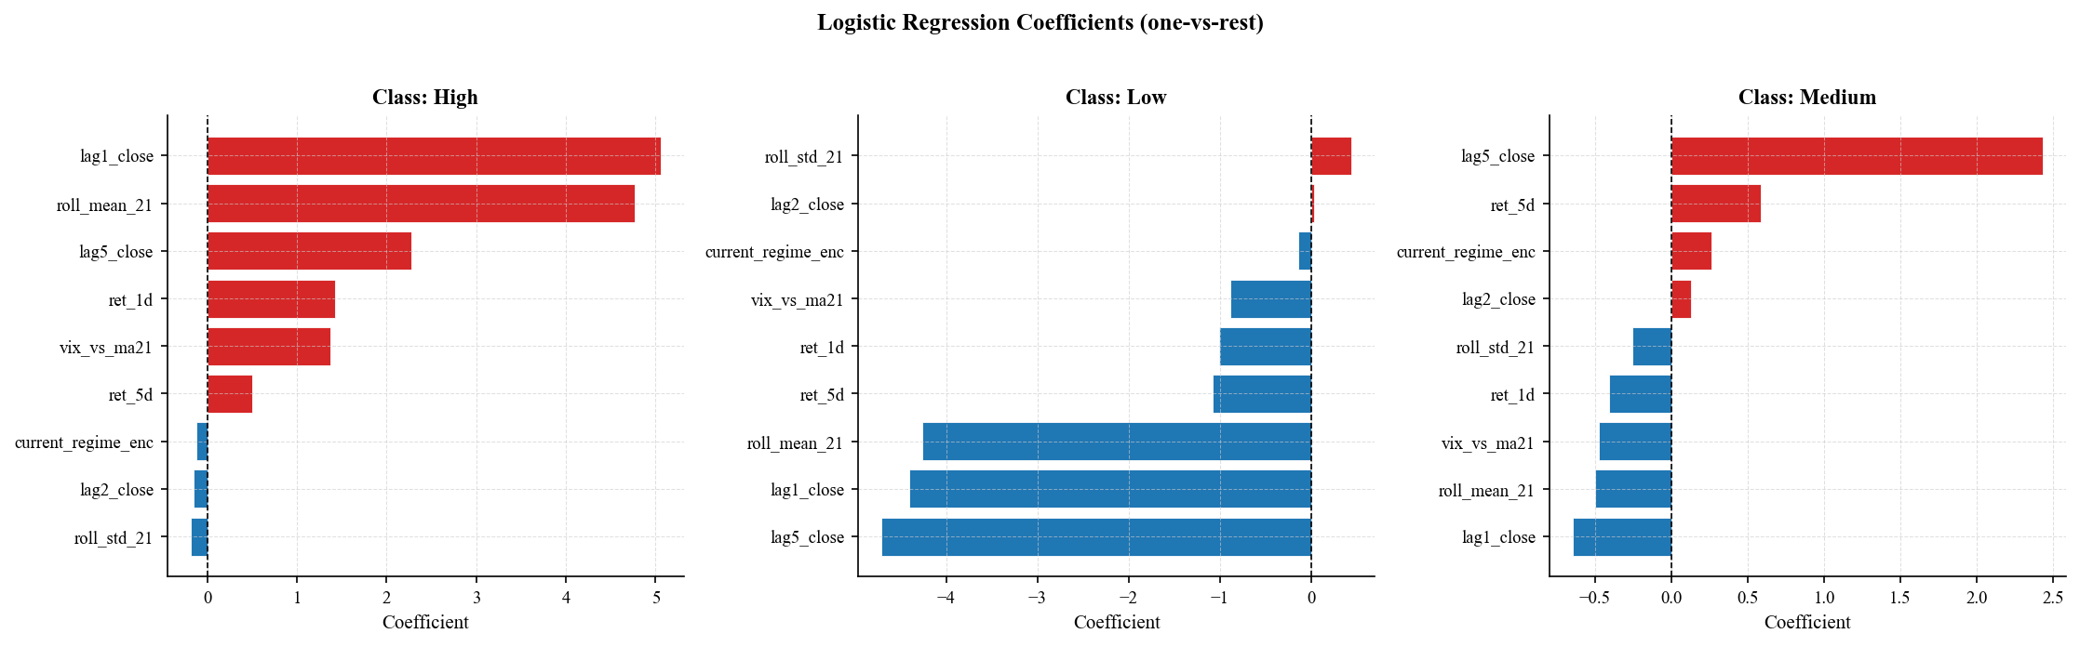
This is a sensible mechanism, but its aggregate effect remains too small to establish meaningful predictive superiority over persistence.

Calibration analysis, although not required by the brief, provides a useful secondary result. Logistic regression achieves a multiclass log-loss of 0.2525, and one-vs-rest reliability diagrams show generally reasonable probability calibration. This suggests that its class probabilities may still be useful as descriptive risk signals even if the point-classification advantage over persistence is negligible.

6. Final solution, limitations, and implications

The central empirical result of this project is that the persistence baseline already captures nearly all of the predictive structure available in the VIX time series. None of the evaluated machine-learning models produces a statistically significant improvement over this rule. Under a McNemar exact test comparing logistic regression with persistence, the observed difference corresponds to p = 0.85, indicating that the performance advantage is indistinguishable from random variation.
From a predictive standpoint, persistence is therefore the correct final model. It achieves the highest defensible level of performance for the given feature set and requires no parameter estimation.
Logistic regression remains informative as an interpretive model. Its coefficients reveal how specific features — particularly the deviation of VIX from its recent moving average — contribute marginally to predicting sustained high-volatility regimes. However, this role is diagnostic rather than predictive: the coefficients describe the structure of the data-generating process rather than delivering a materially better forecast. The same null conclusion holds for the strongest nonlinear specification evaluated, the PyTorch DeepMLP, confirming that additional architectural complexity is not the binding constraint within a VIX-only feature set.

The most fundamental limitation of this study arises from the nature of the VIX itself. VIX is an options-implied volatility measure and therefore already reflects market expectations about future uncertainty. Predicting tomorrow’s VIX regime using only historical VIX values means attempting to extract additional signal from a series that already embeds forward-looking information.

The second limitation follows from the feature set. All predictors are derived from the same underlying series, which restricts the information available to the models. Even sophisticated algorithms cannot generate predictive signal that is absent from the input data.

These two constraints jointly imply that the ceiling on predictive performance is determined primarily by market forecasting efficiency rather than by model architecture. The results therefore illustrate an important methodological point: when the underlying process already aggregates forward-looking information, improvements from purely historical predictors are necessarily limited.

Future work should therefore focus specifically on improving prediction of regime transitions rather than continuation days. The most promising direction is to incorporate variables observable at time t that may signal stress before it appears in implied volatility, such as equity-index returns, realised volatility measures, or credit spreads. Because transition days represent the dominant source of error across all models, any feature capable of providing early information about regime shifts would directly address the principal limitation identified in this study.

A second extension would be to explore alternative regime definitions that adapt to changing long-run volatility levels, for example using training-window quantiles instead of fixed thresholds. Probabilistic forecasting approaches may also be useful for monitoring volatility risk even when improvements in point classification remain small.

Appendix A. Agent Usage Log and Decision Register
Project stage | Agent contribution | Verification performed | Decision
Problem framing | Suggested reframing VIX prediction as regime classification rather than raw-value forecasting | Checked that regime formulation matched the implemented target y_t = R(C_{t+1}) | Accepted
EDA | Proposed class-balance, autocorrelation, and transition-matrix diagnostics | Reproduced all outputs in the notebook and checked that the quantitative findings were consistent with the plots | Accepted
Feature engineering | Proposed lagged closes, rolling summaries, and momentum-style features | Verified all engineered variables used only information available at or before time t | Modified
Evaluation | Proposed alternative metrics | Rejected suggestions that could obscure minority-class performance; retained macro F1 as primary metric | Modified
Debugging | Proposed plotting logic that depended on manually maintained feature-name lists | Restarted kernel and reran notebook end-to-end; discovered that coefficient plots failed under clean execution because feature names were not robustly tied to the fitted model matrix | Rejected and corrected
Example of agent error identified.
An agent-generated plotting suggestion for the logistic-regression coefficient charts relied on manually maintained feature-name variables rather than the training matrix used to fit the model. This introduced a reproducibility bug: the notebook could fail when executed from a clean kernel if those names were not defined in the expected order. The issue was caught by restarting the kernel and rerunning the notebook end-to-end. The plotting logic was then refactored so that feature names were derived directly from the fitted model input, improving idempotence and reproducibility.

First Agent Log Entry

Stage | What I asked | What it produced | Decision | Why
Setup | Asked Claude to propose repo structure for a reproducible ML project | Folder structure with src/, data/, outputs/, tests/ | Modified | Removed a proposed config/ folder as unnecessary for this scope

